**Learning Outcomes**

1. Understanding ActionBarSherlock

**ActionBars**

The action bar is a window feature that identifies the user location, and provides user actions and navigation modes. Using the action bar offers your users a familiar interface across applications that the system gracefully adapts for different screen configurations.

The [ActionBar](http://developer.android.com/reference/android/app/ActionBar.html) APIs were first added in Android 3.0 (API level 11) but they are also available in the [Support Library](http://developer.android.com/tools/support-library/index.html) for compatibility with Android 2.1 (API level 7) and above.

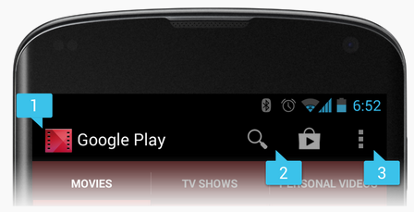

**Sherlock Action Bar**

ActionBarSherlock is a Java Android library that brings action bar feature, which became available in Android 4.0 API, to Android 2.x too.

Start a new Project name it ActionBarDemo

Add the ActionbarSherlock component from the Component Store

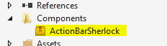

Double click the component, select the samples tab and open the sample

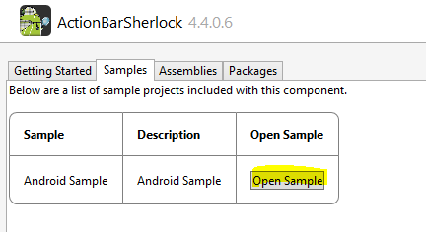

Build and Run the Action bar Sherlock project. (Play around with the app and understand its features)

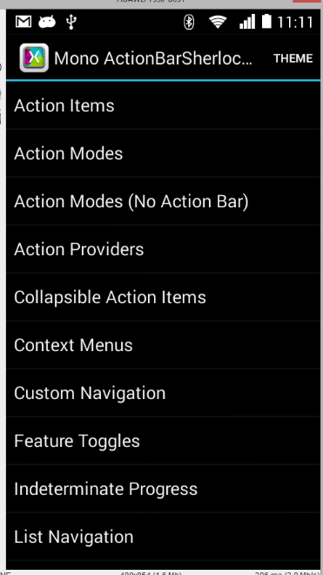

We will try to add some of the features to our project.

Create a New Solution name it ActionBarSherlockDemo

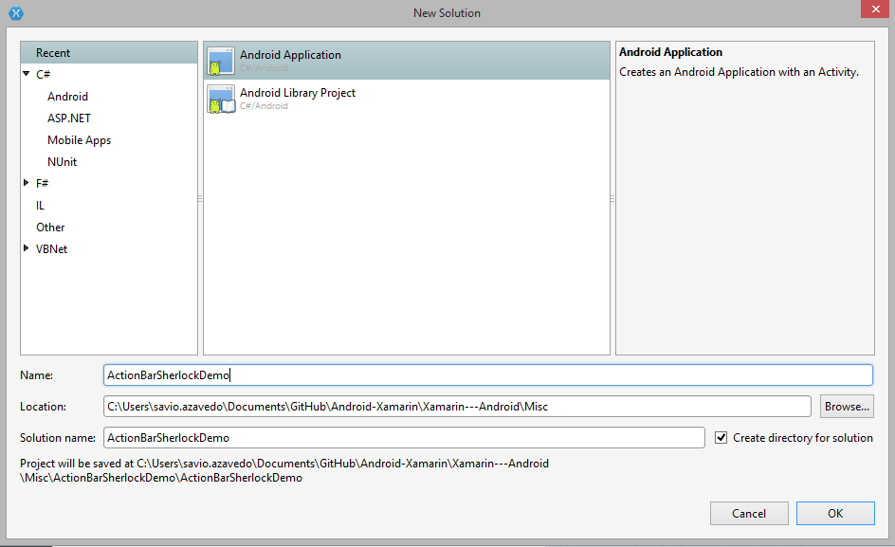

Search for Actionbar Sherlock in components and add it to your project.

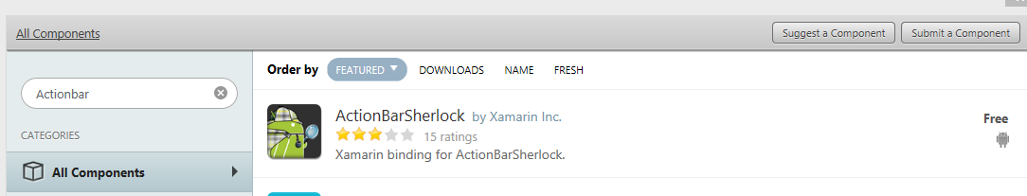

When you add the component it automatically adds the reference to the library.

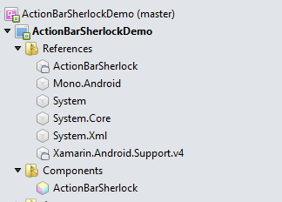

Before doing anything just build the complete project.

1. **Adding Action Items**

We will add some action items on the ActionBar.

In MainActivity.cs import a bunch of libraries.

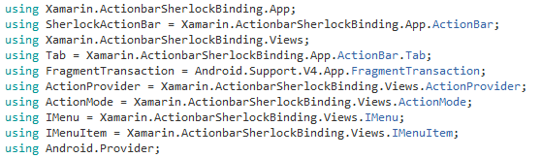

Copy it down from the ActionBarSherlockTest project.

Next important change is to inherit the Activity as SherlockActivity.

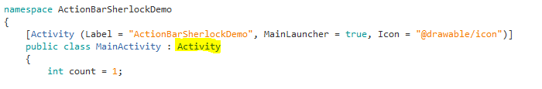

**To**

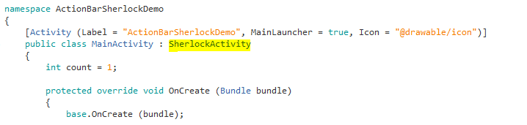

Now to add ActionItems on the ActionBar, write the following code on the OnCreateOptionsMenu

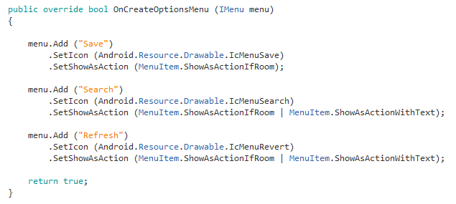

Run the program to get the following output.

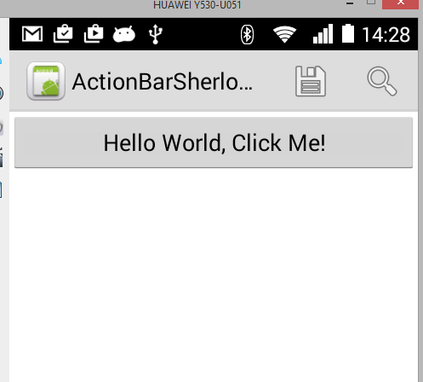

Handling the click event of the Action Items.

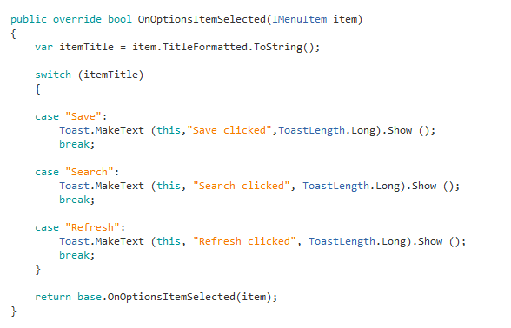

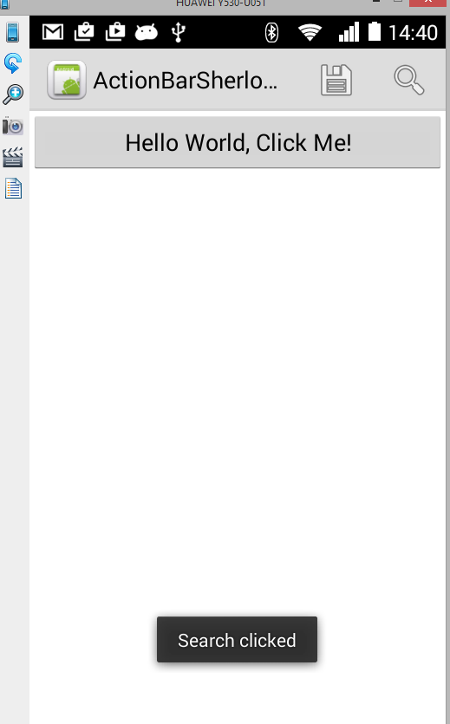

**Search Activity using Sherlock ActionBar**

Adding Search to the ContactList App

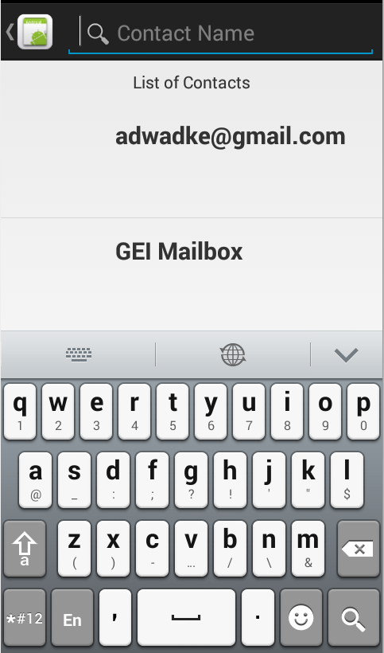

Copy the ContactList app that you have made and make the following changes

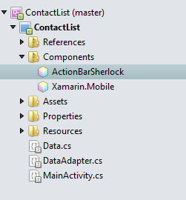

using Android.Support.V4.Widget;  
using Xamarin.ActionbarSherlockBinding;  
using Xamarin.ActionbarSherlockBinding.App;  
using Xamarin.ActionbarSherlockBinding.Views;  
using Xamarin.ActionbarSherlockBinding.Widget;  
using SherlockActionBar = Xamarin.ActionbarSherlockBinding.App.ActionBar;  
using SearchView = Xamarin.ActionbarSherlockBinding.Widget.SearchView;  
using CursorAdapter = Android.Support.V4.Widget.CursorAdapter;  
using IMenu = Xamarin.ActionbarSherlockBinding.Views.IMenu;

Change your Activity to SherlockActivity

Also add the SearchViewInterface, don’t forget to set the theme

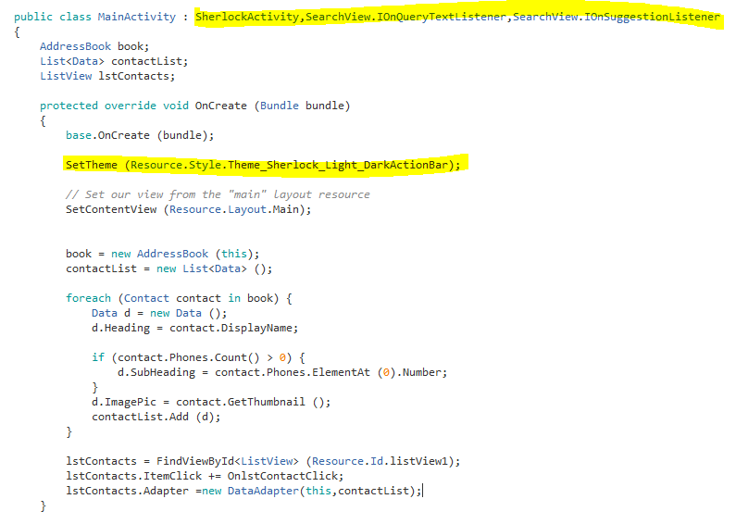

Implement the Interface functions

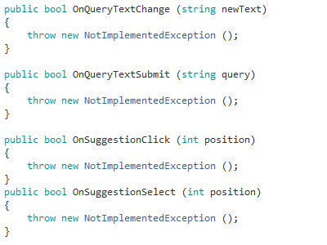

In OnCreateOptionsMenu add the SearchView

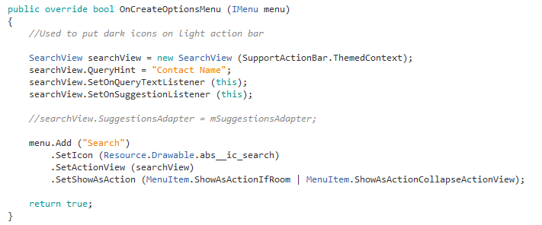

Modify the OnQueryTextChange and OnQueryTextSubmit functions

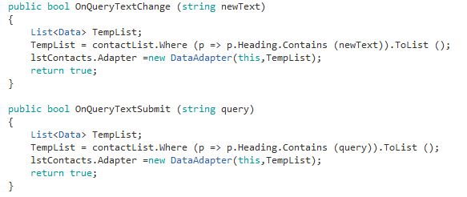

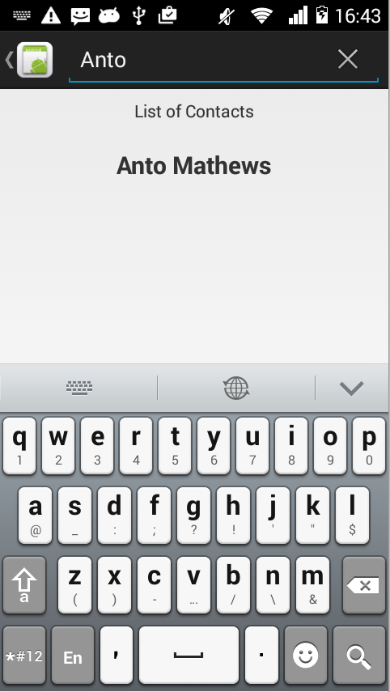

**Exercise**

1. ReMake your ToDoList app with SherlockActionBar

